1. FMBBC – Budget
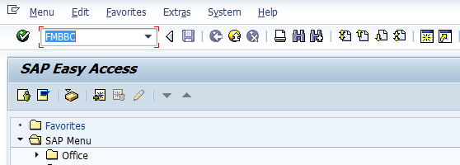
- Input FMBBC in Transaction box and press Enter key
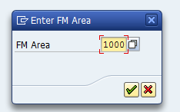
- Input the FM Area 1000 in the field and press Ok button
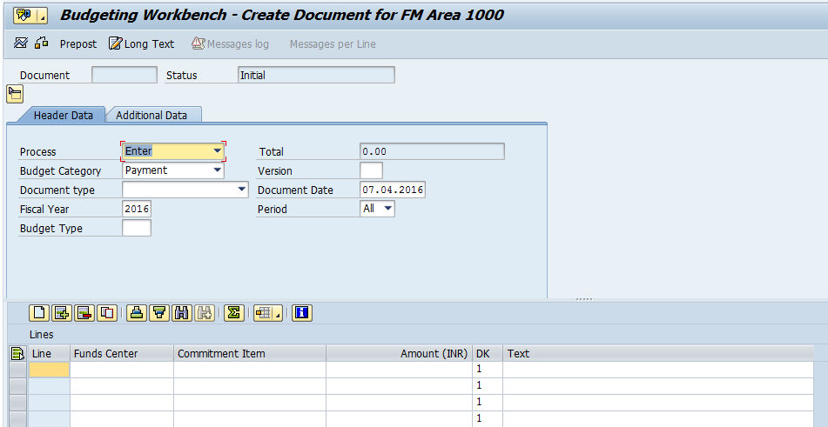

1.1. Header data:
The following are the input fields in the Header section of the Budget
- Process: Place the cursor on this field and press F4 and select the respective process and press enter key Eg: Enter
- Budget Category: Place the cursor on this field and press F4 and select the respective Budget category and press enter key Eg: Payment
- Version: Input the version number 0
- Document type: Place the cursor on this field and press F4 and select the respective Document type and press enter key Eg: BINT(Initial Budget Entry)
- Document date: Input the Document date
- Fiscal Year: Input the Fiscal Year
- Budget type: Place the cursor on this field and press F4 and select the respective Budget type and press enter key Eg: BI(Initial)
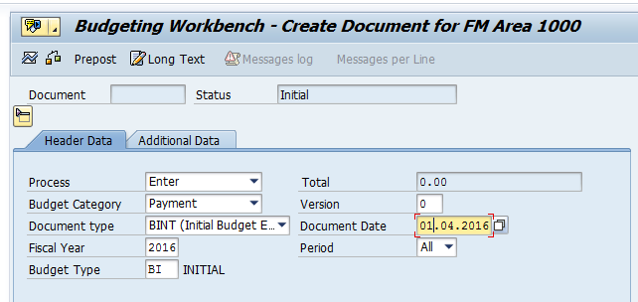

1.2. Line item
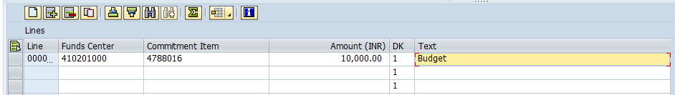
The following are the Input fields in the Line item section.
- Fund Center: Place the cursor on this field and press F4 and select the respective Fund Center and press enter key Eg: 410201000
- Commitment Item: Place the cursor on this field and press F4 and select the respective Commitment item and press enter key Eg: 4788016
- Amount: Input the Budget amount
- Text: Input the Text information in this field

1.3 Save and Display
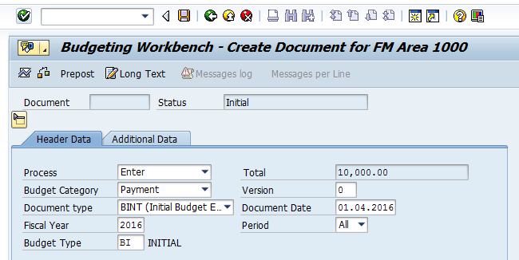
- Click on Save option
- System will pop up Document has been created successfully message at the bottom of the screen.
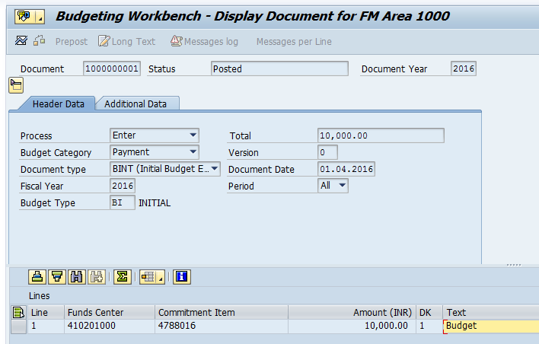

2. Transfer:
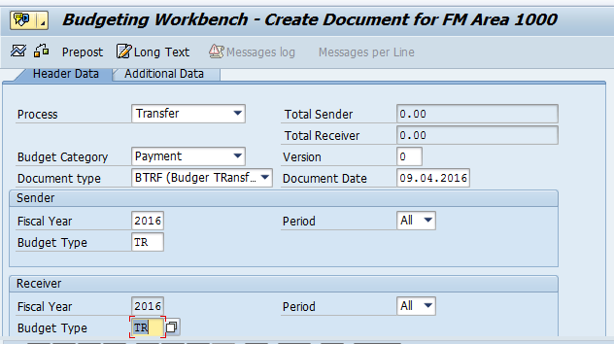

2.1. Header data:
The following are the input fields in the Header section of the Budget
- Process: Place the cursor on this field and press F4 and select the respective process and press enter key Eg: Transfer
- Budget Category: Place the cursor on this field and press F4 and select the respective Budget category and press enter key Eg: Payment
- Version: Input the version number 0
- Document type: Place the cursor on this field and press F4 and select the respective Document type and press enter key Eg: BRTF(Budget Transfer)
- Document date: Input the Document date
- Fiscal Year: Input the Fiscal Year
- Budget type: Place the cursor on this field and press F4 and select the respective Budget type and press enter key Eg: TR (Budget Transfer)
Note: Need to select the Budget Type for both SENDER and RECEIVR Section

2.2. Line item
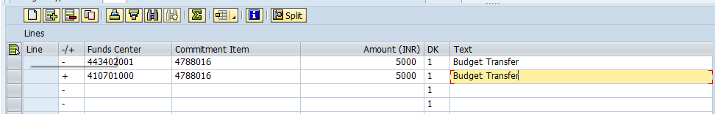
The following are the Input fields in the Line item section.
- Fund Center: Place the cursor on this field and press F4 and select the respective Fund Center and press enter key Eg: 443420001
- Commitment Item: Place the cursor on this field and press F4 and select the respective Commitment item and press enter key Eg: 4788016
- Amount: Input the Budget transfer amount
- Text: Input the Text information in this field
Note: Need to select the Fund center Sender with “-“symbol and Receiver with “+”symbol

2.3 Save and Display
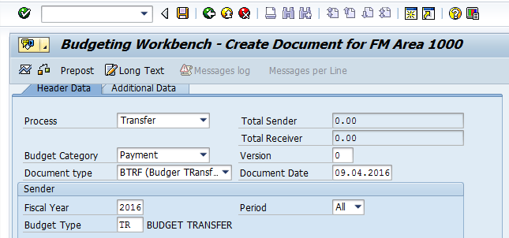
- Click on Save option
- System will pop up Document has been created successfully message at the bottom of the screen.
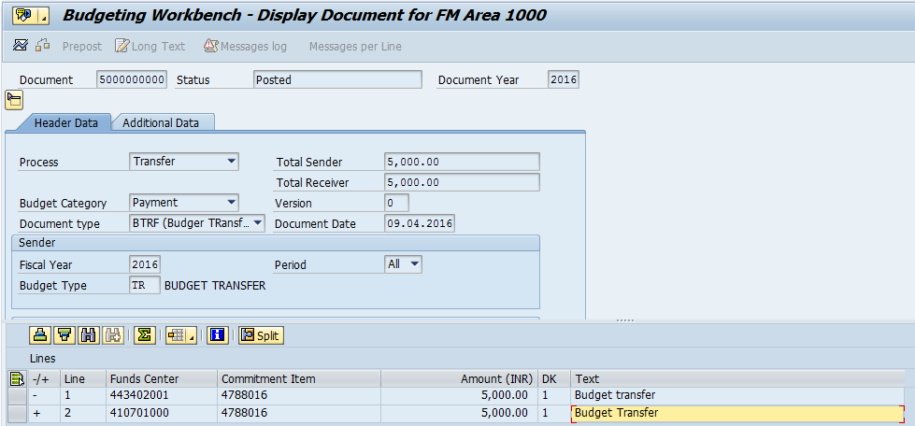

3. Return
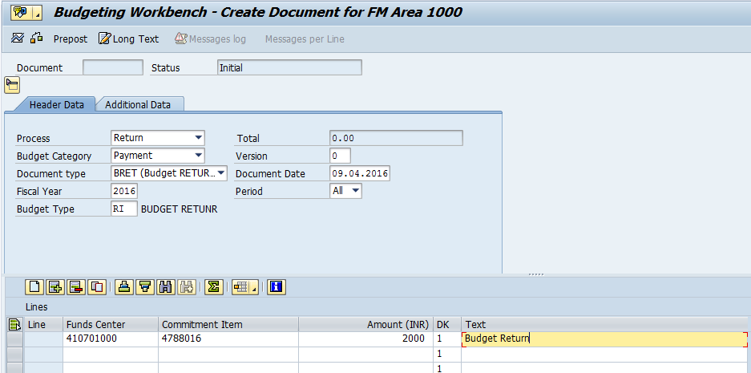

3.1. Header data:
The following are the input fields in the Header section of the Budget
- Process: Place the cursor on this field and press F4 and select the respective process and press enter key Eg: Retrun
- Budget Category: Place the cursor on this field and press F4 and select the respective Budget category and press enter key Eg: Payment
- Version: Input the version number 0
- Document type: Place the cursor on this field and press F4 and select the respective Document type and press enter key Eg: BRET (Budget Return)
- Document date: Input the Document date
- Fiscal Year: Input the Fiscal Year
- Budget type: Place the cursor on this field and press F4 and select the respective Budget type and press enter key Eg: RI (Budget Return)

3.2. Line item
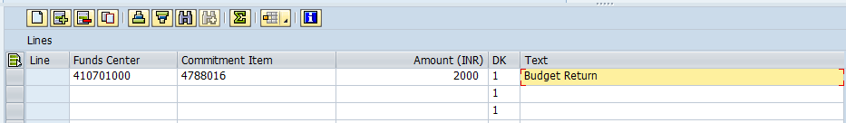
The following are the Input fields in the Line item section.
- Fund Center: Place the cursor on this field and press F4 and select the respective Fund Center and press enter key Eg: 410701000
- Commitment Item: Place the cursor on this field and press F4 and select the respective Commitment item and press enter key Eg: 4788016
- Amount: Input the Budget amount
- Text: Input the Text information in this field

3.3 Save and Display
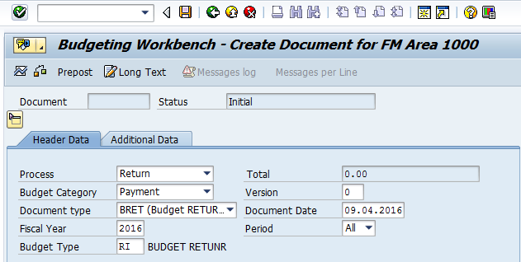
- Click on Save option
- System will pop up Document has been created successfully message at the bottom of the screen.
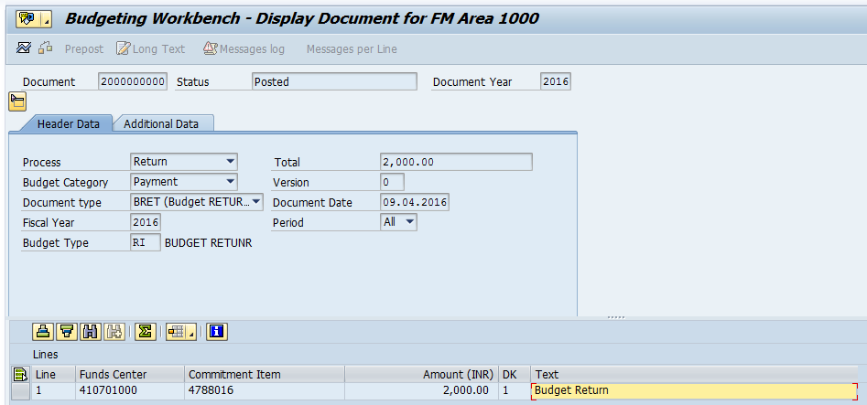

4. Supplement:
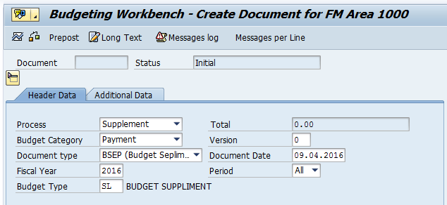

4.1. Header data:
The following are the input fields in the Header section of the Budget
- Process: Place the cursor on this field and press F4 and select the respective process and press enter key Eg: Supplement
- Budget Category: Place the cursor on this field and press F4 and select the respective Budget category and press enter key Eg: Payment
- Version: Input the version number 0
- Document type: Place the cursor on this field and press F4 and select the respective Document type and press enter key Eg: BSEP(Budget Supplement)
- Document date: Input the Document date
- Fiscal Year: Input the Fiscal Year
- Budget type: Place the cursor on this field and press F4 and select the respective Budget type and press enter key Eg: SL (Budget Supplement)

4.2. Line item
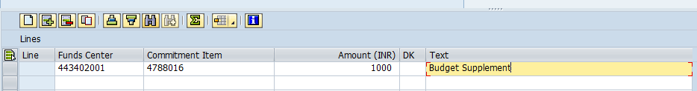
The following are the Input fields in the Line item section.
- Fund Center: Place the cursor on this field and press F4 and select the respective Fund Center and press enter key Eg: 443420001
- Commitment Item: Place the cursor on this field and press F4 and select the respective Commitment item and press enter key Eg: 4788016
- Amount: Input the Budget amount
- Text: Input the Text information in this field

4.3 Save and Display
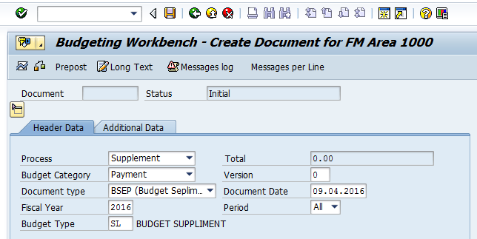
- Click on Save option
- System will pop up Document has been created successfully message at the bottom of the screen.
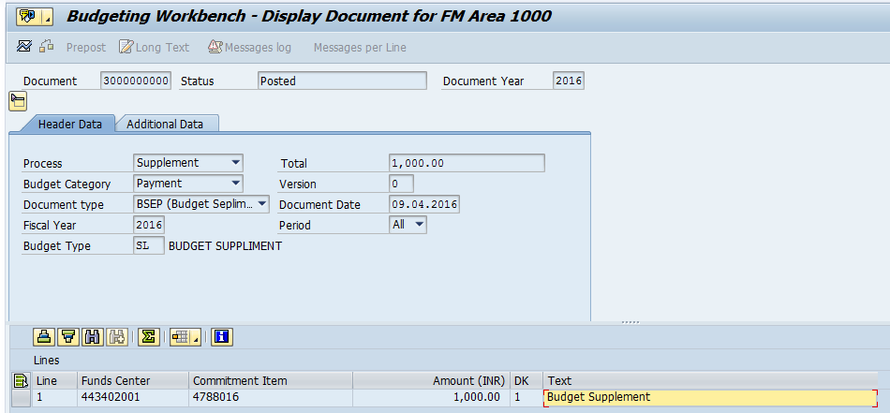

Manual End

